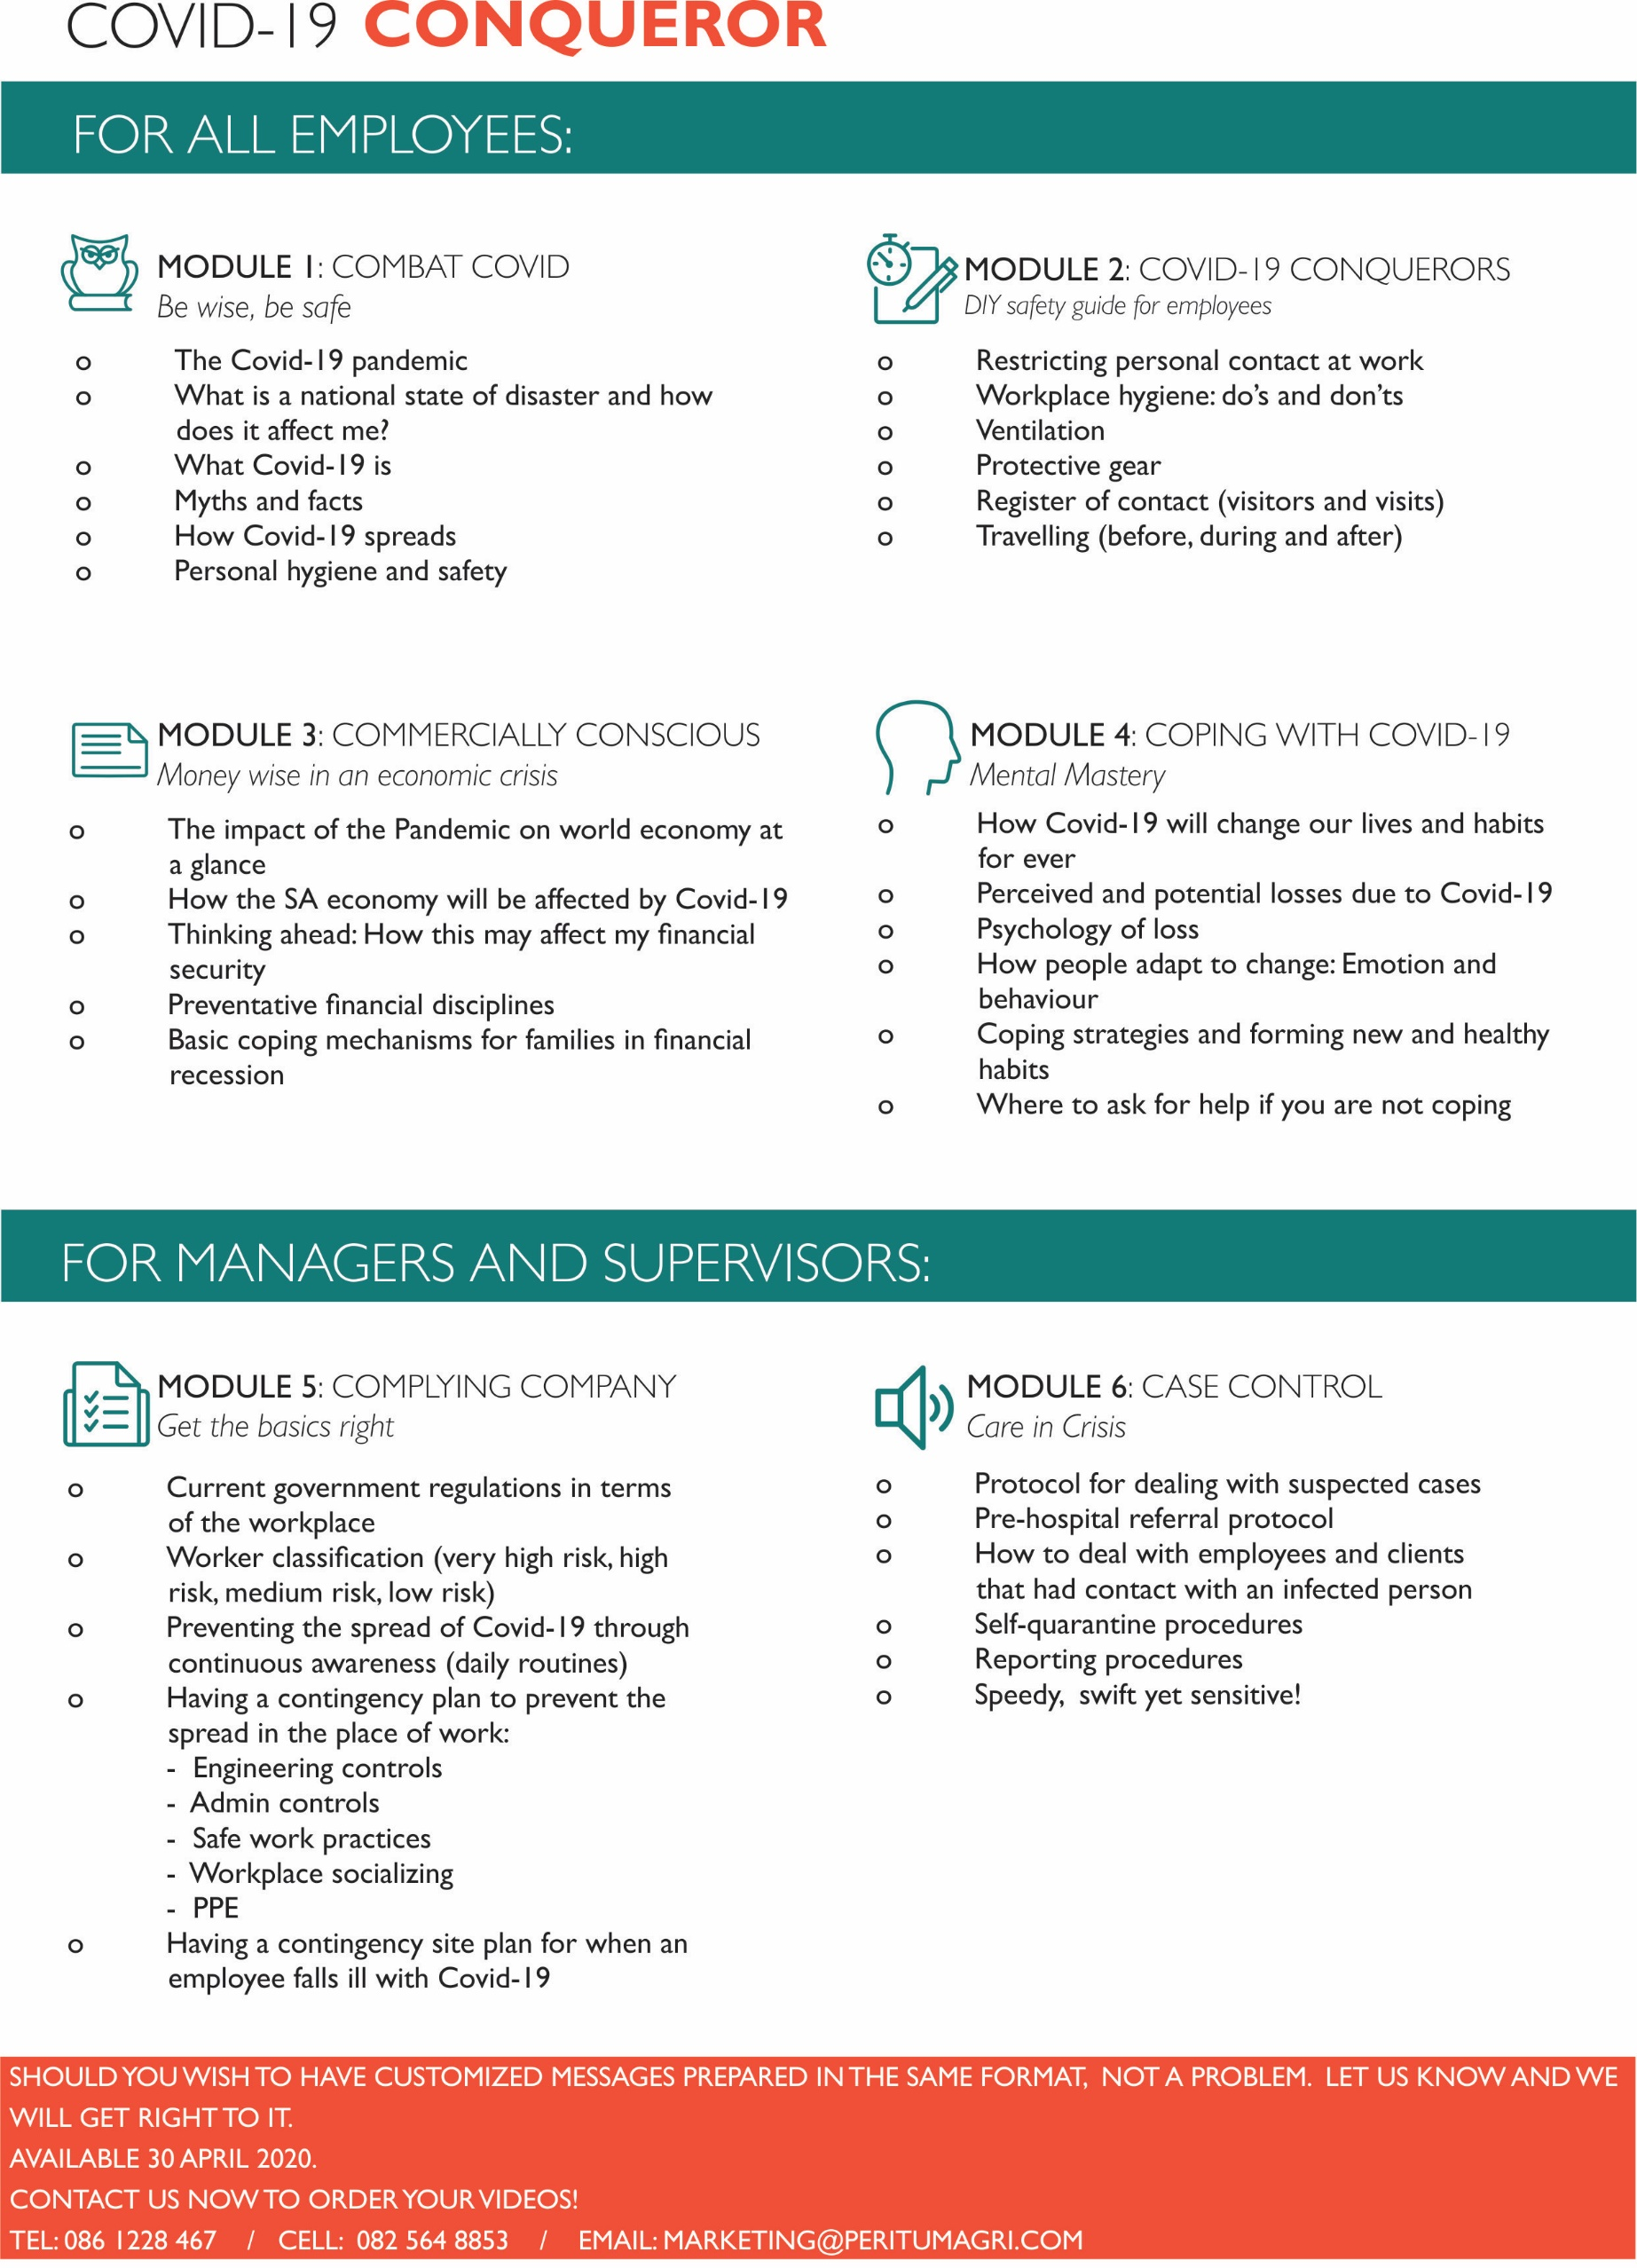

PERITUM INSTITUTE
Toll-free: 0861 228 467
E-mail: info@peritumagri.com

COVID CONQUERER COMIC SERIES FOR BUSINESS
Order form / Quotation
Video: Please tick
Video | Cost | Vat | Total Cost | Please tick
Module 1: Combat COVID!  Be wise, be safe | R8 000 | R1 200 | R9 200
Module 2: COVID 19 Conquerors  DIY safety guide for employees | R8 000 | R1 200 | R9 200
Module 3: COVID 19 Commercially Conscious Money wise in an economic crisis | R8 000 | R1 200 | R9 200
Module 4: Coping with COVID 19  Mental Mastery | R8 000 | R1 200 | R9 200
Module 5: Complying Company  Get the basics right | R8 000 | R1 200 | R9 200
Module 6: Case control  Care in crises | R8 000 | R1 200 | R9 200
Set of 6 videos | R40 000 | R6 000 | R46 000

INVOICE DETAILS
Organization (if applicable)
Order no (if applicable)
Postal Address
Vat Number (if applicable)
Name of responsible officer
Designation
Telephone number |  | E-mail
Peritum Banking details:
ABSA Branch code: 632005 Account no: 4054315055 Account type: Cheque

