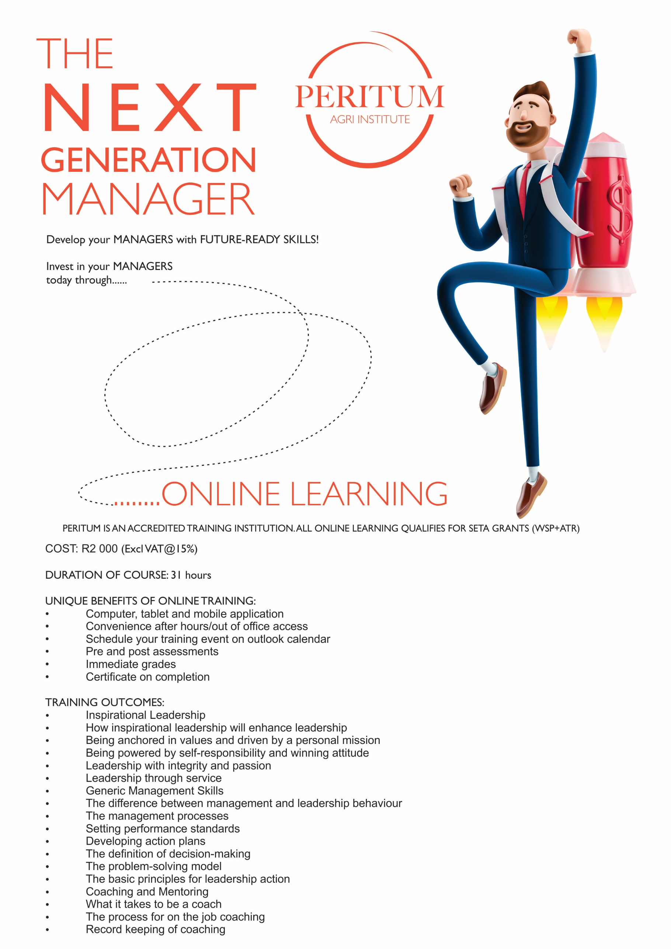

PERITUM INSTITUTE
Toll-free: 0861 228 467
E-mail: info@peritumagri.com

Online Training Enrollment Form
Peritum is an accredited training institution - all online learning qualifies for Seta grants
(WSP + ATR)

Personal Data:
Surname |  |  | Initials
Full Names
Email address |  |  | Contact number
ID number:

Training module: Please tick
Module | Duration | Cost | Vat | Total Cost | Please tick
The Professional Secretary | 24 hours | R1 700 | R255 | R1 955
Creative selling techniques | 23 hours | R1 700 | R255 | R1 955
Employee engagement in the workplace | 20 hours | R1 700 | R255 | R1 955
Essential skills for supervisors | 20 hours | R1700 | R255 | R1 955
The next generation Manager | 31 hours | R2 000 | R300 | R2 300
Customer Centric Service | 16 hours | R1 500 | R225 | R1 725
The HR Advisor | 29 hours | R2 500 | R375 | R2 875

INVOICE DETAILS – the link to the course will be send once full payment has been received
Organization (if applicable)
Postal Address
Vat Number (if applicable)
Name of responsible officer
Designation
Telephone number |  | E-mail

Peritum Banking details:
ABSA Branch code: 632005 Account no: 4054315055 Account type: Cheque

Terms and conditions:
- Two months to complete the learning module
- Pass rate of 80%

